**Project Design Phase-2**

**Data Flow Diagram & User Stories**

|  |  |
| --- | --- |
| **Date** | **14 October 2022** |
| **Team ID** | **PNT2022TMID13481** |
| **Project Name** | **IoT based smart crop protection system for agriculture** |
| **Maximum Marks** | **4 Marks** |

**DATA FLOW DIAGRAM:**

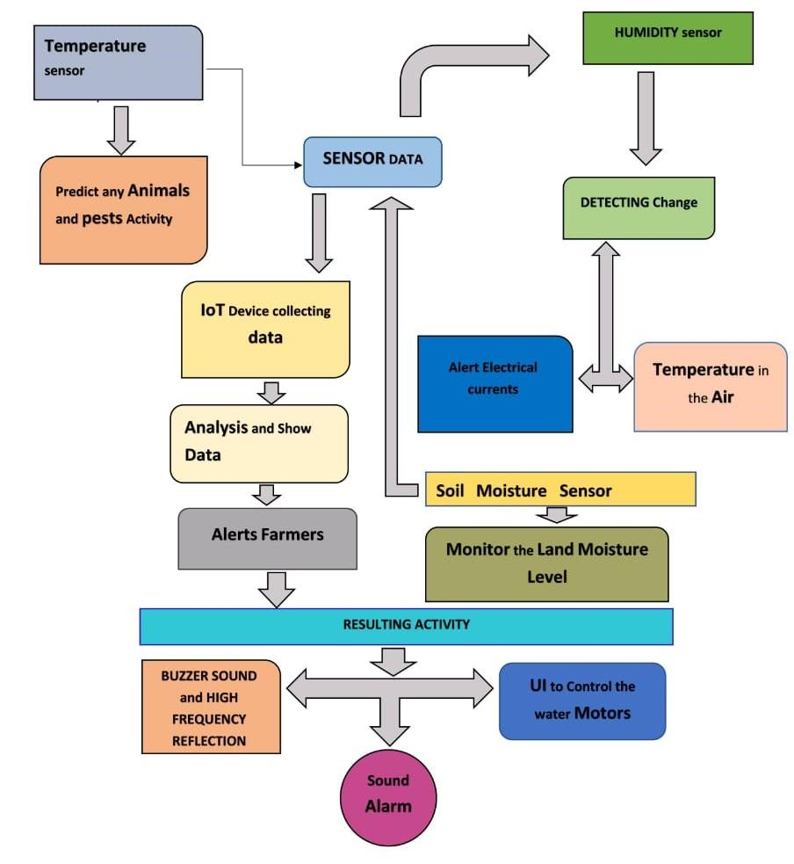

|  |  |  |  |  |  |  |
| --- | --- | --- | --- | --- | --- | --- |
| **User Type** | **Functional requirement (Epic)** | **User Story**  **numbe**  **r** | **User Story/Task** | **Acceptancecr**  **iteria** | **Priority** | **Release** |
| **Customer (Mobile user)** | **Registration** | **USN-1** | **User can enter into the web application** | **I can access my account /dashboard** | **High** | **Sprint 1** |
|  |  | **USN-2** | **User can register their credentials like email id and password** | **Ican receive confirmation email & click confirm** | **High** | **Sprint 1** |
|  | **Login** | **USN-3** | **User can log into the application by entering email & password** | **I can login to my account** | **High** | **Sprint 1** |
|  | **Dashboard** | **USN-4** | **User can view the temperature** | **I can view the data given by the device** | **High** | **Sprint 2** |
|  |  | **USN-5** | **User can view the level of sensor monitoring value** | **I can view the data given by the device** | **High** | **Sprint 2** |
| **Customer (Web**  **user)** | **Usage** | **USN-1** | **User can view the web ppage and get the information** | **I can view the data given by the device** | **High** | **Sprint 3** |
| **Customer** | **Working** | **USN-1** | **User act according to the alert given by the device** | **I can get the data work**  **according to**  **it** | **High** | **Sprint 3** |
|  |  | **USN-2** | **User turns ON the water motors/Buzzer/Soun d Alarm when occur the disturbance on field.** | **I can get the data work**  **according to**  **it** |  | **Sprint 4** |
| **Customer care Executive** | **Action** | **USN-1** | **User solve the problem when some**  **faces any usage issues** | **Ican solve the issues**  **when some**  **one fails to understandin g the procedure** | **High** | **Sprint 4** |
| **Administ ration** | **Administratio n** | **USN-1** | **User store every information** | **I can store the gained information** | **High** | **Sprint 4** |